

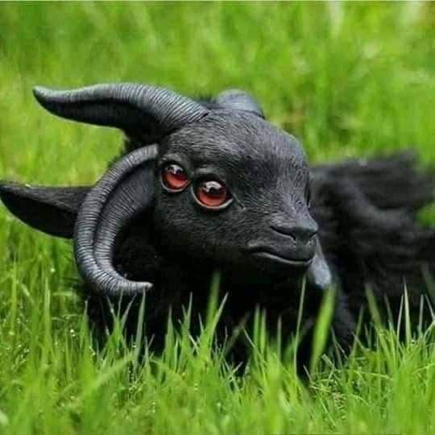

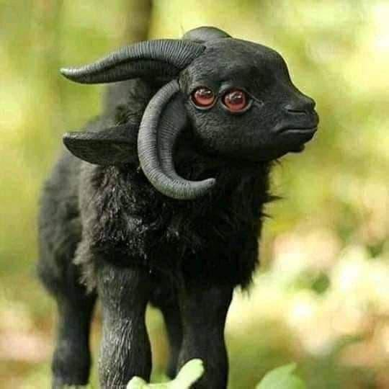

**Image Forensic Report**

According to my forensics, the above two photos have been shared multiple times on social media alongside a claim that it shows a four-eyed goat like an animal that was reportedly discovered in South Sudan. It had also gone viral on social media.

**The photos are real, but the claim is false because the animal of the photos is not real. The photos show a figurine of a Basque mythical creature made by Spanish artist Alvaro Herranz.**

**Provement:**

### The animal of the photos is not real:

(1) To do those forensics, I performed a reverse image search(<https://images.google.com/>) and found that the photo was uploaded on the Instagram page named “fuegofatuoart”( <https://www.instagram.com/fuegofatuoart>). This Instagram page belongs to Spanish artist Alvaro Herranz who is a sculptor and a creative artist. His main influence is on instagram and he creates a lot of magical creature using sculpts, silicon, fur and other materials and put them in context in pictures. ( <http://www.fuegofatuo.es/p/sobre.html>).

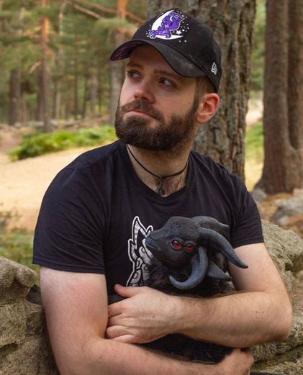

Alvaro Herranz with his creation Akerbeltz

(<https://www.instagram.com/p/CHkuNAWlLpo/?utm_source=ig_web_copy_link>)

Alvaro Herranz had uploaded those photos with two individual posts. The posts were:

**First Post**:

“[EN] Well, well... Samhain (or Halloween or whatever you celebrate) is approaching and I was planning to list the preorders for my Akerbeltz on that night, but I am afraid many people will be out celebrating, which means I should probably choose another day. So I am thinking about listing them next friday, October 25th, at 6:06:06 pm (I would do it in the morning, but I don’t want to get up that early for a release 🤣). I know it might be a weird hour and I am not sure about how sucessful it will be, but I wanted it to be 666 time 🤣🤣 So remember: We have a date next October 25th at 18:06:06 (Spanish peninsular time GMT+2) in my Etsy shop (link in bio). Put a little darkness in your life!

[ES] Bueno, bueno... Samaín (o Halloween o lo que celebréis) se acerca y, aunque quería abrir la preventa de Akerbeltz esa noche, me imagino que muchxs de vosotrxs andaréis de fiesta, así que he pensado que finalmente haré la preventa este viernes, 25 de octubre, a las 6:06:06 p.m. (lo haría por la mañana, pero no pienso madrugar tanto para una venta online 🤣). Sé que es una hora un poco rara y no sé qué tal funcionará, pero me hace gracia que fuera a las 666 🤣🤣 Así que recordad: tenemos una cita el viernes 25 de octubre, a las 18:06:06 (hora española peninsular GMT+2) en mi tienda de Etsy (enlace en mi bio). ¡Poned un poquito de oscuridad en vuestras vidas!  
[#AkerBeltz](https://www.instagram.com/explore/tags/akerbeltz/) [#Euskadi](https://www.instagram.com/explore/tags/euskadi/) [#EuskalHerria](https://www.instagram.com/explore/tags/euskalherria/) [#EuskalMitologia](https://www.instagram.com/explore/tags/euskalmitologia/) [#Coven](https://www.instagram.com/explore/tags/coven/) [#Aquelarre](https://www.instagram.com/explore/tags/aquelarre/) [#BabyGoat](https://www.instagram.com/explore/tags/babygoat/) [#goat](https://www.instagram.com/explore/tags/goat/) [#MitologiaVasca](https://www.instagram.com/explore/tags/mitologiavasca/) [#BasqueMythology](https://www.instagram.com/explore/tags/basquemythology/) [#Artdoll](https://www.instagram.com/explore/tags/artdoll/) [#dollart](https://www.instagram.com/explore/tags/dollart/) [#Devil](https://www.instagram.com/explore/tags/devil/) [#Dollartist](https://www.instagram.com/explore/tags/dollartist/) [#Doll](https://www.instagram.com/explore/tags/doll/) [#fantasydoll](https://www.instagram.com/explore/tags/fantasydoll/) [#poseabledoll](https://www.instagram.com/explore/tags/poseabledoll/) [#creaturedoll](https://www.instagram.com/explore/tags/creaturedoll/) [#creatureart](https://www.instagram.com/explore/tags/creatureart/) [#creaturedesign](https://www.instagram.com/explore/tags/creaturedesign/) [#MagicalCreature](https://www.instagram.com/explore/tags/magicalcreature/) [#Phillip](https://www.instagram.com/explore/tags/phillip/) [#BlackPhillip](https://www.instagram.com/explore/tags/blackphillip/) [#BigPhillip](https://www.instagram.com/explore/tags/bigphillip/) [#LilPhillip](https://www.instagram.com/explore/tags/lilphillip/) [#etsy](https://www.instagram.com/explore/tags/etsy/) [#etsyfantasy](https://www.instagram.com/explore/tags/etsyfantasy/) [#Etsyshop](https://www.instagram.com/explore/tags/etsyshop/) [#EtsySale](https://www.instagram.com/explore/tags/etsysale/)”

(<https://www.instagram.com/p/B34fnYYotIP/?utm_source=ig_web_copy_link>)

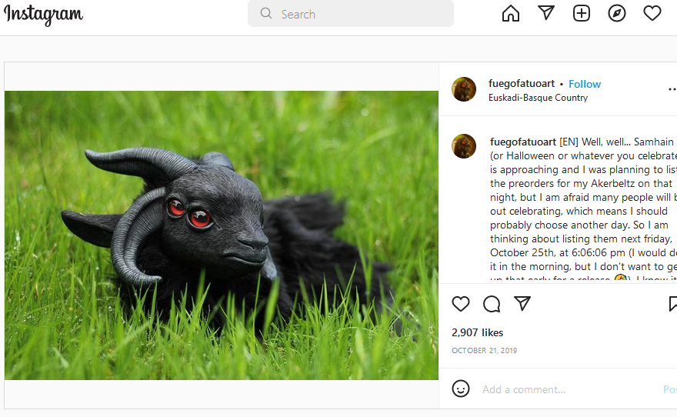

**Second Post:**

**“**Let me introduce you this little baby Akerbeltz. Akerbeltz is a mythical creature from Basque mythology in northern Spain. Originally considered a nature and animals protector, its link to witches and covens from the ancient ages made christian religion consider them evil creatures related with the devil. Whichever simbolism you prefer to believe in, it seems a good creature for this spooky season of the year. What do you think?

[EN] ¡Permitidme presentaros a esta nueva criatura: un cabritillo de Akerbeltz! El Akerbeltz es una figura perteneciente a la mitología vasca, en el norte de España. Originalmente considerados protectores de la naturaleza y los animales, su estrecha vinculación con las brujas y sus aquelarres, hizo que la religión criatiana les ganara mala fama asociándolos con el demonio. Sea cual sea el simbolismo que queráis darle, parece una criatura apropiada para esta época del año. ¿Qué opináis?  
[#AkerBeltz](https://www.instagram.com/explore/tags/akerbeltz/) [#Euskadi](https://www.instagram.com/explore/tags/euskadi/) [#EuskalHerria](https://www.instagram.com/explore/tags/euskalherria/) [#EuskalMitologia](https://www.instagram.com/explore/tags/euskalmitologia/) [#Coven](https://www.instagram.com/explore/tags/coven/) [#Aquelarre](https://www.instagram.com/explore/tags/aquelarre/) [#BabyGoat](https://www.instagram.com/explore/tags/babygoat/) [#goat](https://www.instagram.com/explore/tags/goat/) [#MitologiaVasca](https://www.instagram.com/explore/tags/mitologiavasca/) [#BasqueMythology](https://www.instagram.com/explore/tags/basquemythology/) [#Artdoll](https://www.instagram.com/explore/tags/artdoll/) [#dollart](https://www.instagram.com/explore/tags/dollart/) [#Devil](https://www.instagram.com/explore/tags/devil/) [#Dollartist](https://www.instagram.com/explore/tags/dollartist/) [#Doll](https://www.instagram.com/explore/tags/doll/) [#fantasydoll](https://www.instagram.com/explore/tags/fantasydoll/) [#poseabledoll](https://www.instagram.com/explore/tags/poseabledoll/) [#creaturedoll](https://www.instagram.com/explore/tags/creaturedoll/) [#creatureart](https://www.instagram.com/explore/tags/creatureart/) [#creaturedesign](https://www.instagram.com/explore/tags/creaturedesign/) [#MagicalCreature](https://www.instagram.com/explore/tags/magicalcreature/) [#Phillip](https://www.instagram.com/explore/tags/phillip/) [#BlackPhillip](https://www.instagram.com/explore/tags/blackphillip/) [#BigPhillip](https://www.instagram.com/explore/tags/bigphillip/) [#LilPhillip](https://www.instagram.com/explore/tags/lilphillip/)”

(<https://www.instagram.com/p/B3hkvbjIFvy/?utm_source=ig_web_copy_link>)

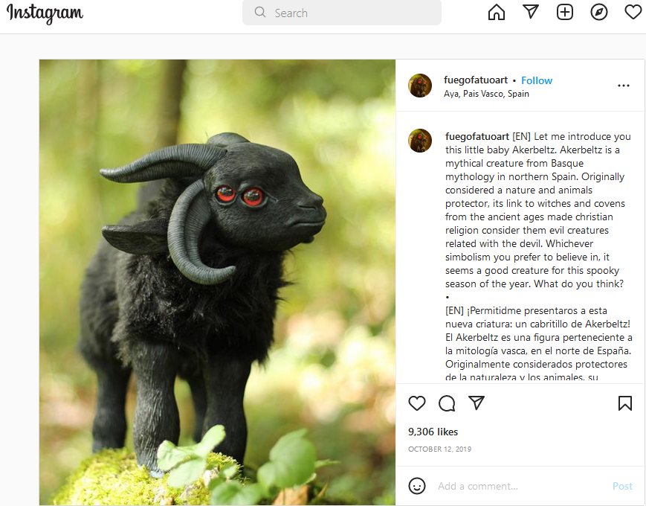

(2) The sculpture Akerbeltz was handmade, about 30cm standing and 38 cm from its nose to the tip of the tail, and weighed around 1,3kg which were described in Etsy (<https://www.etsy.com/>).

The description was:

“This listing is for a handmade, fully poseable baby akerbeltz, a mythical creature from Basque mythology. It measures about 30cm standing and 38 cm from its nose to the tip of the tail and weights around 1,3kg.  
  
The face, legs, ears and horns have been casted in poliurethane resin from original pieces hand modeled by me and painted with acrylics painted with acrylics. Eyes are custom taxidermy glass eyes.  
  
The body is made using faux fur fabrics, which are cut and hand sewn following a sewing pattern designed by me especially for this creature. This sculpture is poseable and can adopt different poses due to its inner armature made with plastic ball and socket pieces.  
  
Note this is not a toy but a collector’s piece of art that must be handled with care as it is delicate. A bad use of it can damage the whole piece and repairing it can be difficult.  
  
  
NOTE: If you live in what DHL considers a "remote area", extra charges might be added to your order's shipping costs. By placing this order you accept to pay those charges if that was necessary. You can check a complete list of remote areas by their zip codes in the following link: <https://www.dhl.com/content/dam/downloads/g0/express/services/surcharges/dhl_express_remote_areas.pdf>”

(<https://www.etsy.com/listing/881376807/akerbeltz-poseable-doll?show_sold_out_detail=1&ref=nla_listing_details>)

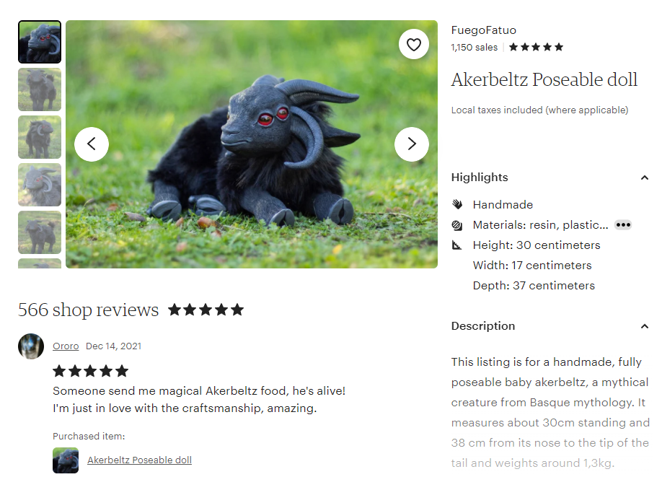

(3) I also found that that sculpture Akerbeltz was available for sale on Etsy

(<https://www.etsy.com/>).

(<https://www.etsy.com/listing/881376807/akerbeltz-poseable-doll?ref=shop_review>)

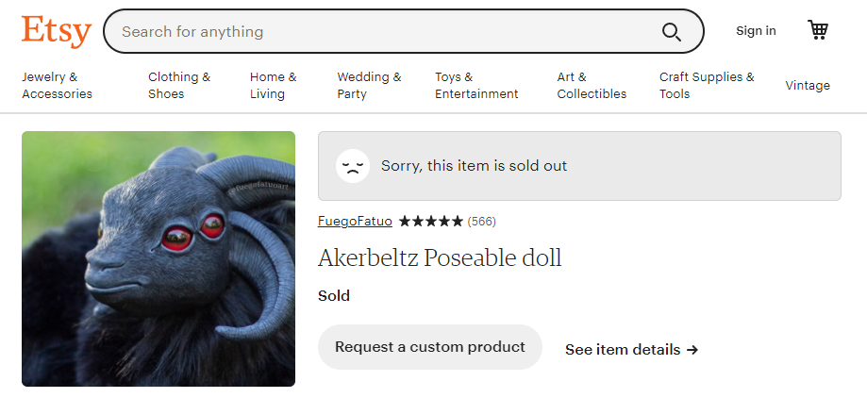

Thus, it proves that that claim is false because the animal of the photos is not real; it is a figurine of a Basque mythical creature made by Spanish artist Alvaro Herranz.

### The photos are not edited:

#### First Photo:

##### Jeffrey's Image Metadata Viewer(<http://exif.regex.info/exif.cgi>):

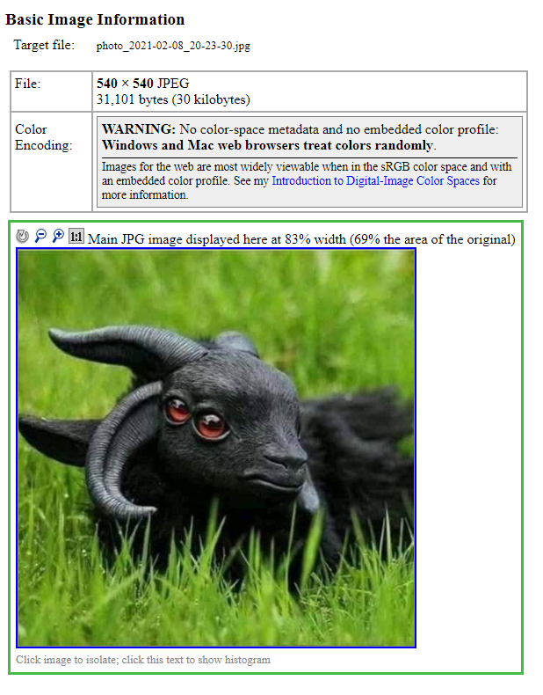

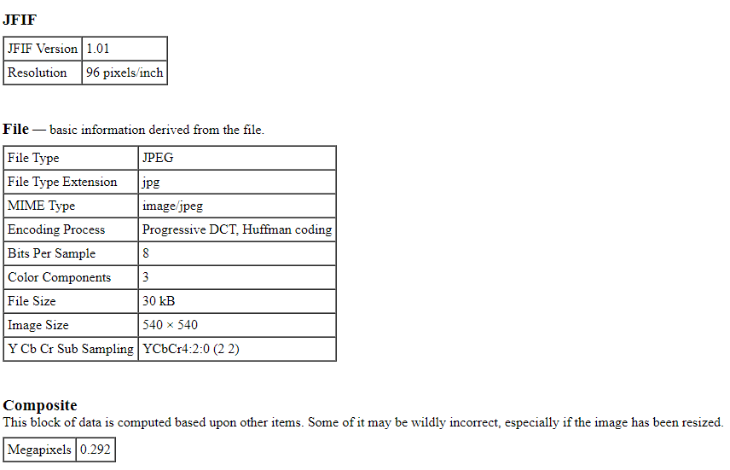

So, Jeffrey's Image Metadata Viewer proves that the first photo is not edited.

##### METADATA2GO (<https://www.metadata2go.com/>):

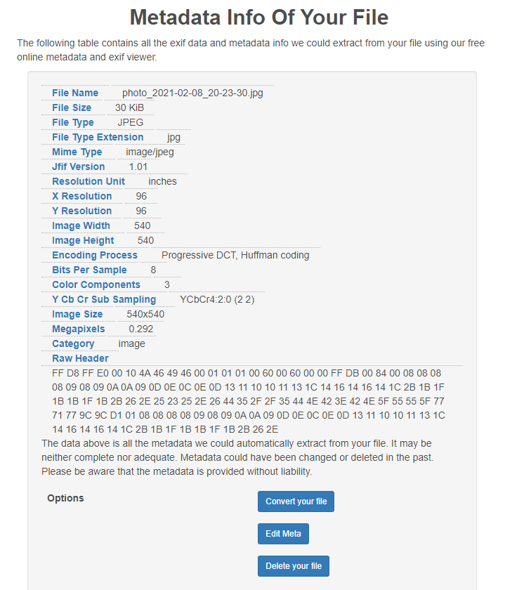So, Metadata2go proves that the first photo is not edited.

##### FotoForensics (<http://fotoforensics.com/>):

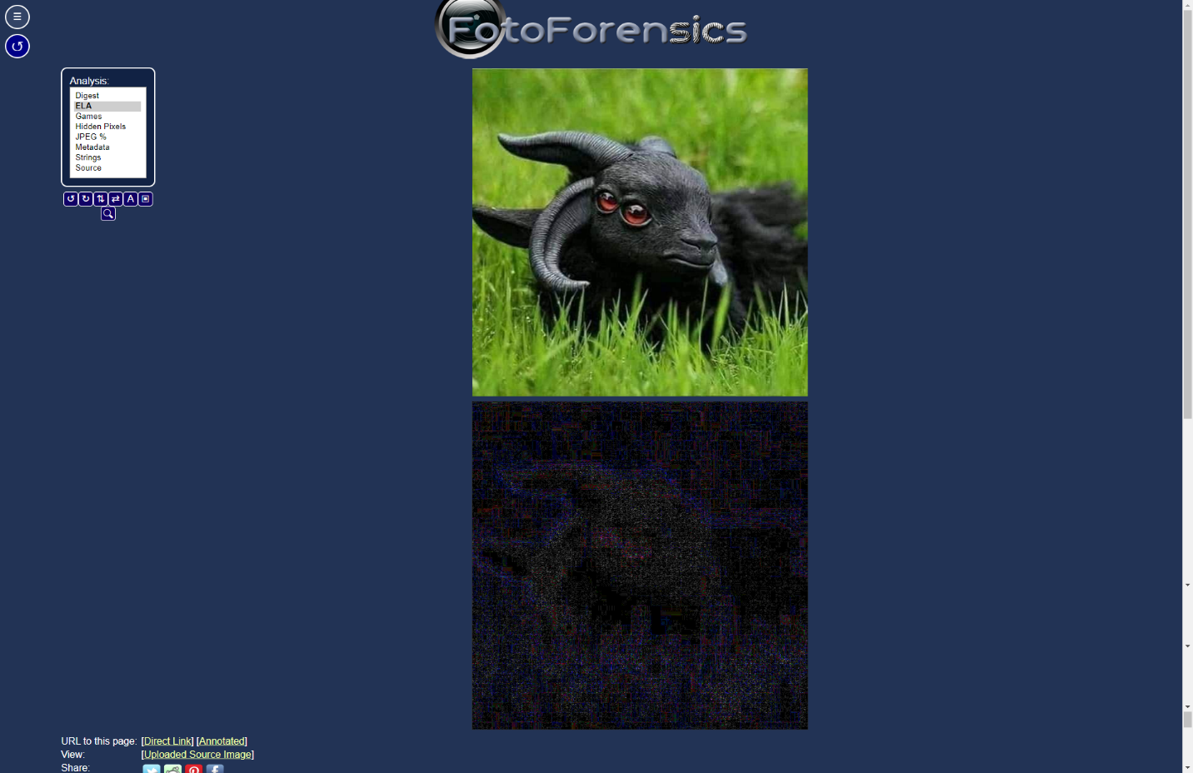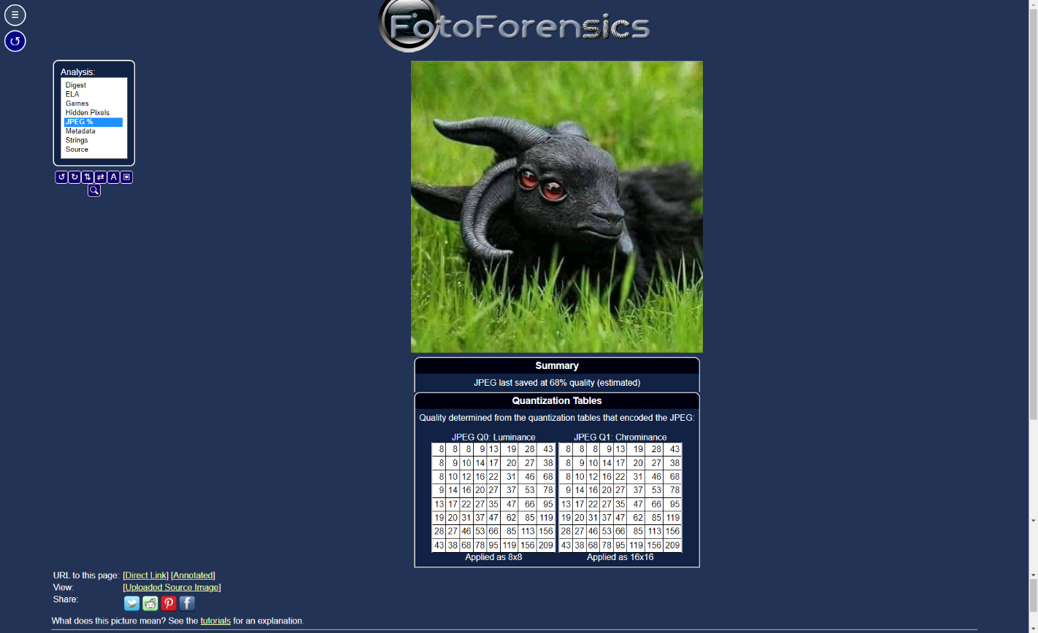

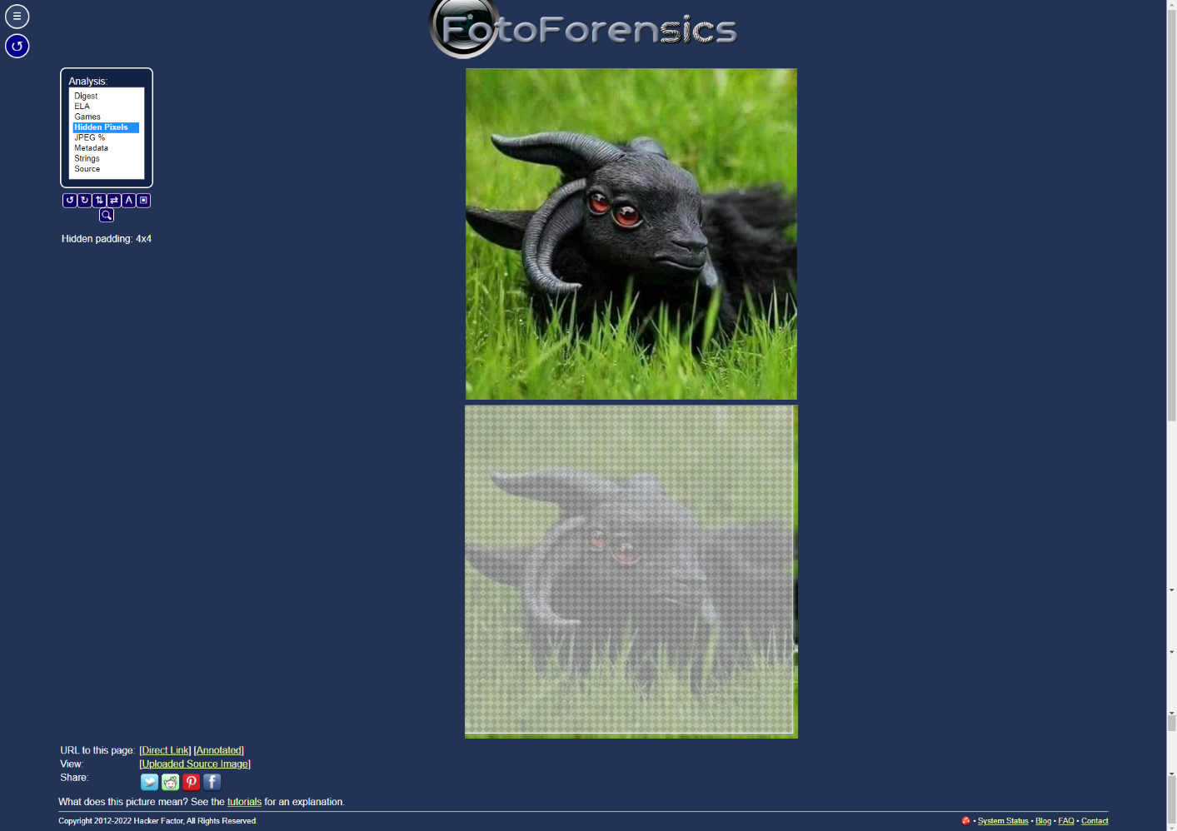

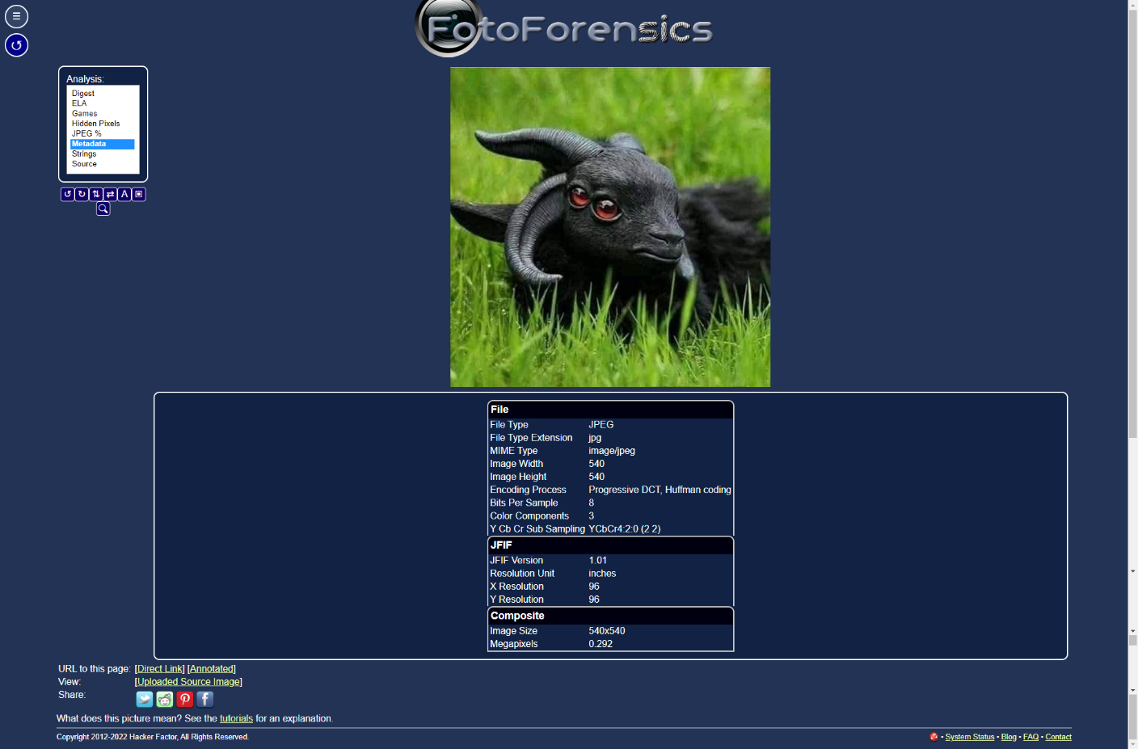

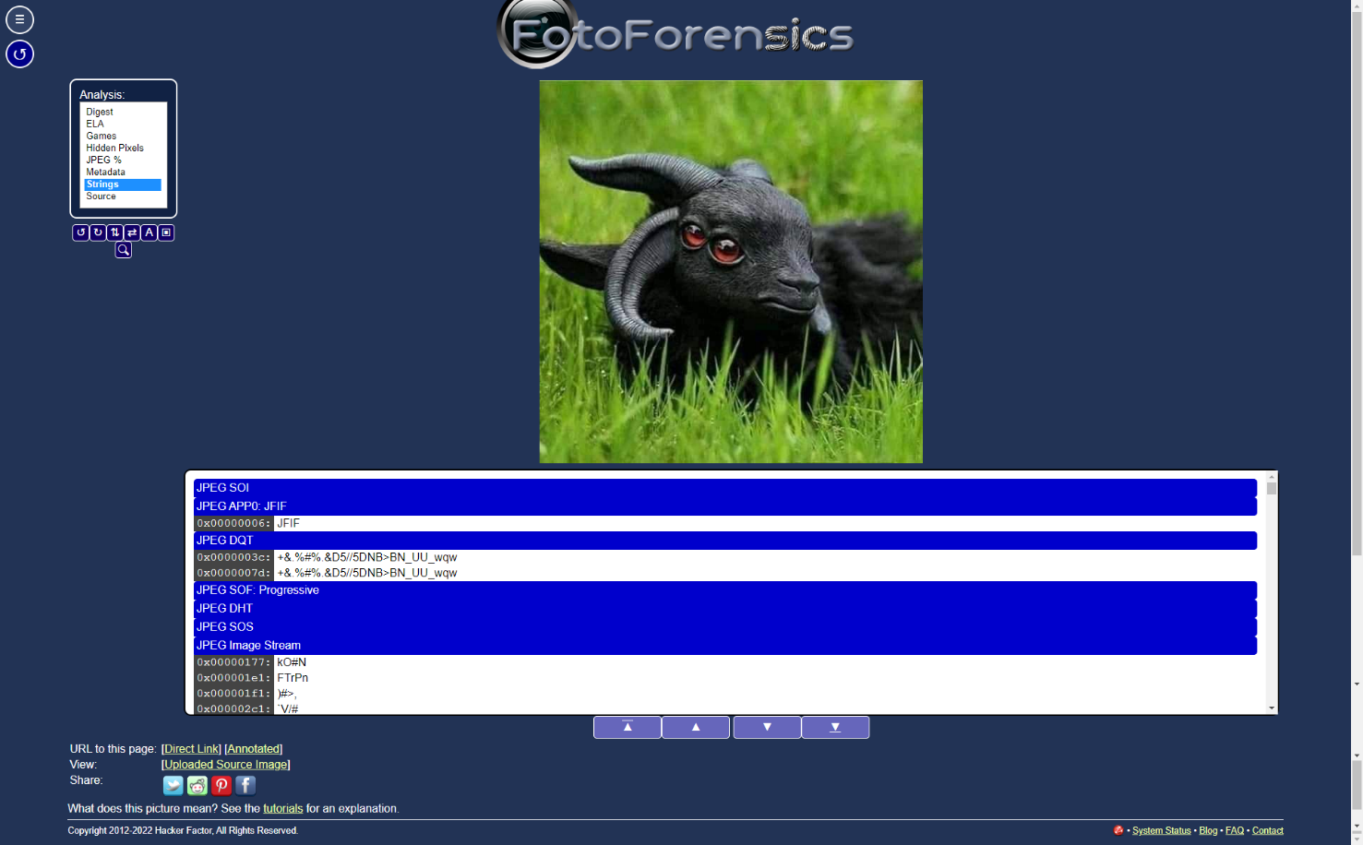

So, FotoForensics proves that the first photo is not edited.

##### Forensically βeta (<https://29a.ch/photo-forensics/#forensic-magnifier>):

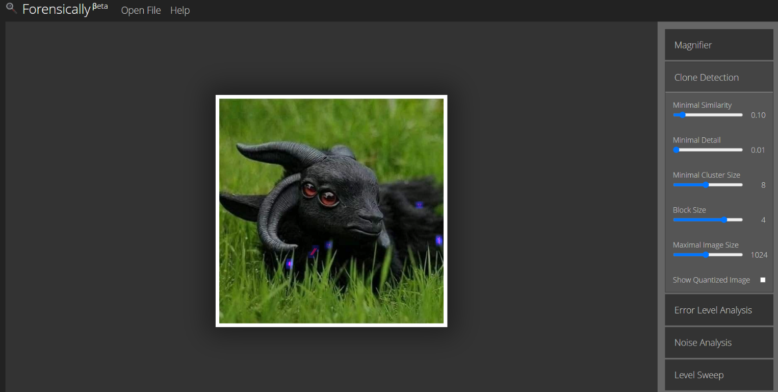

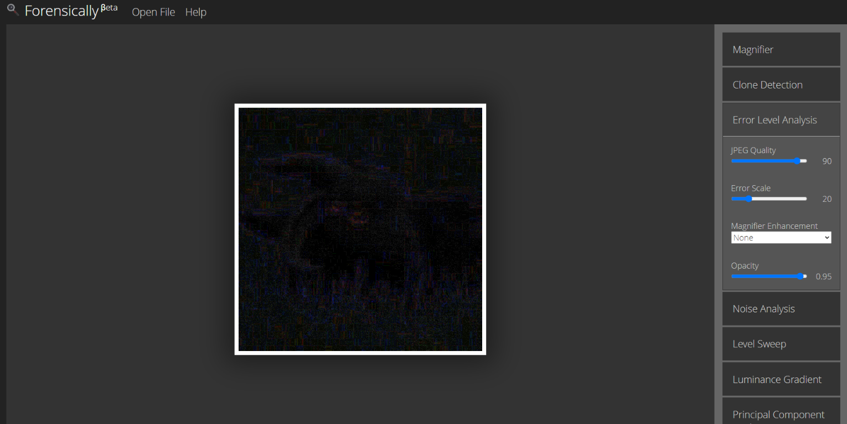

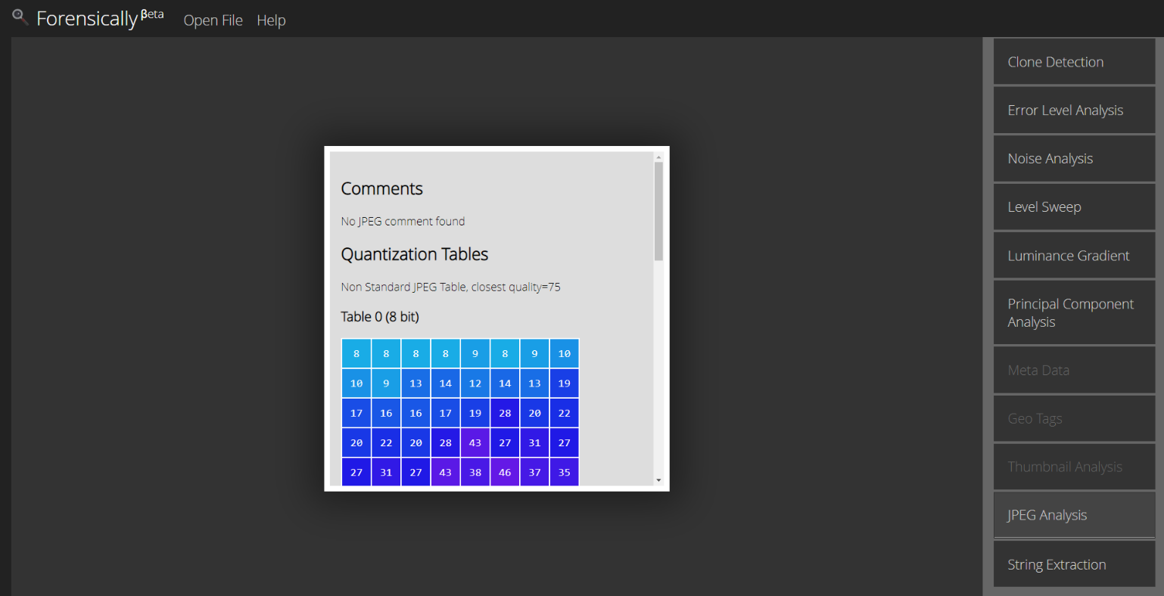

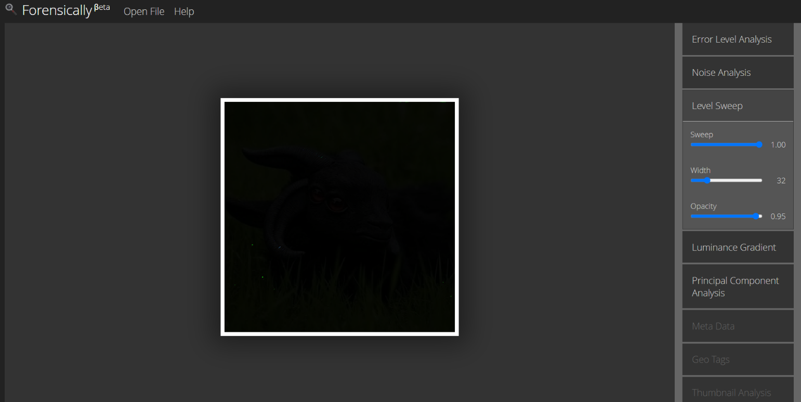

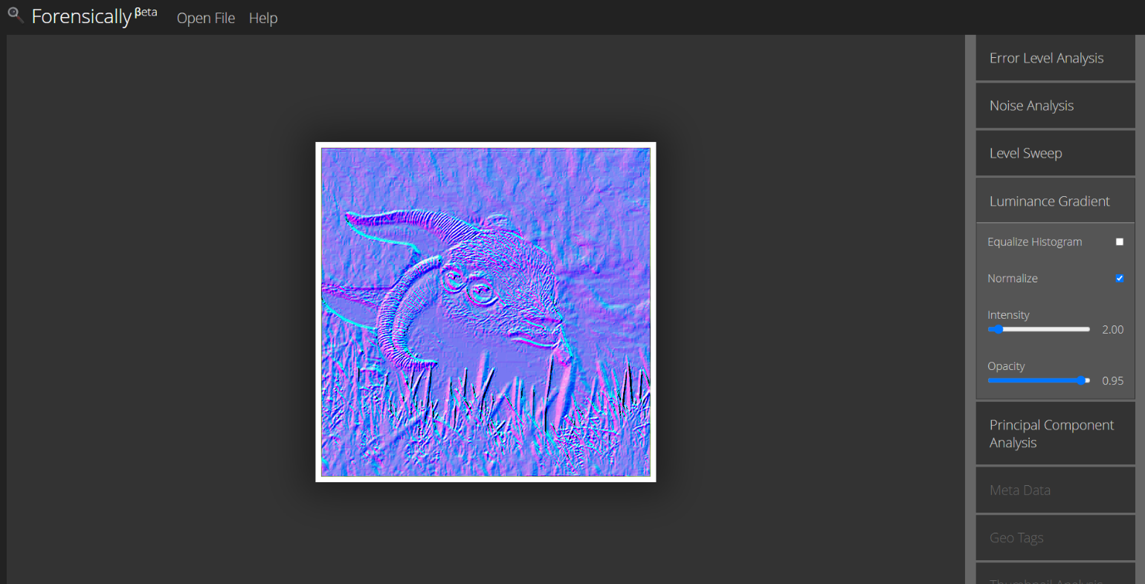

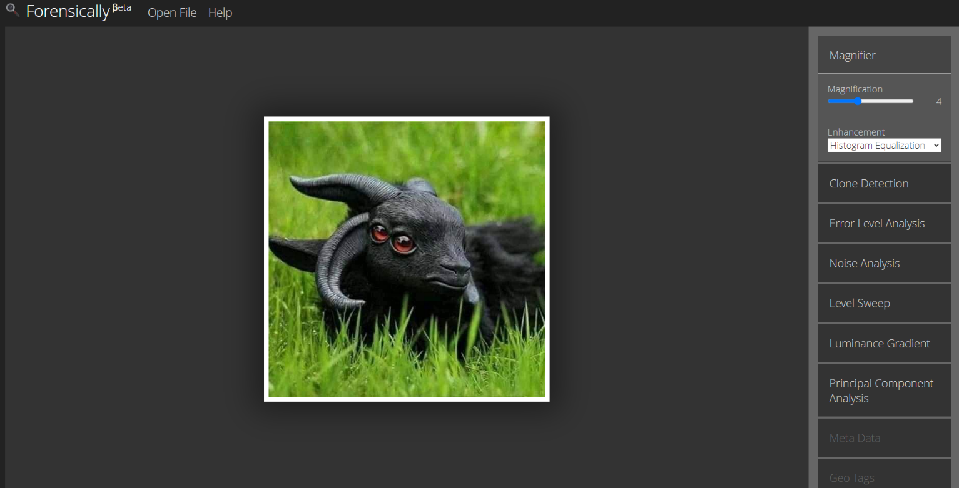

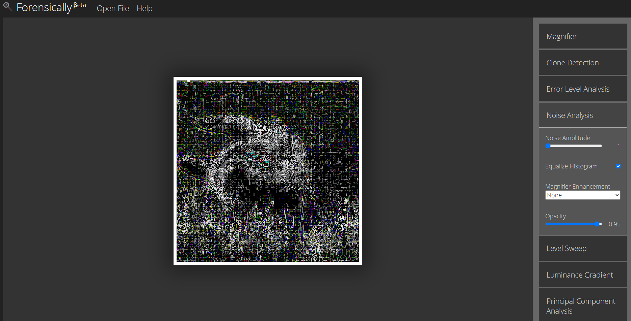

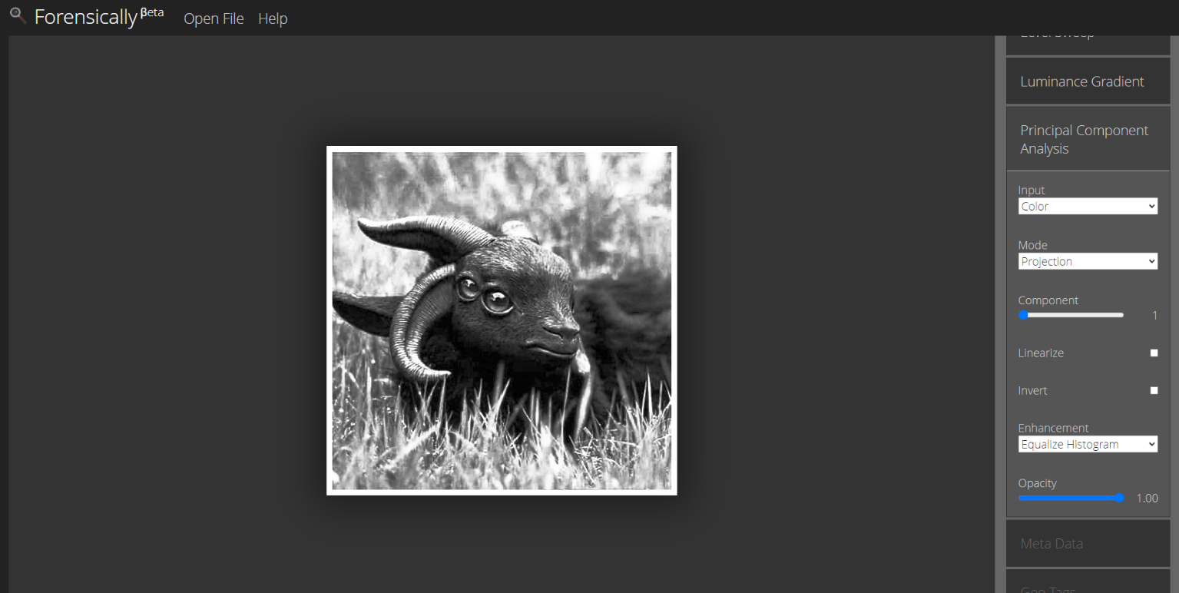

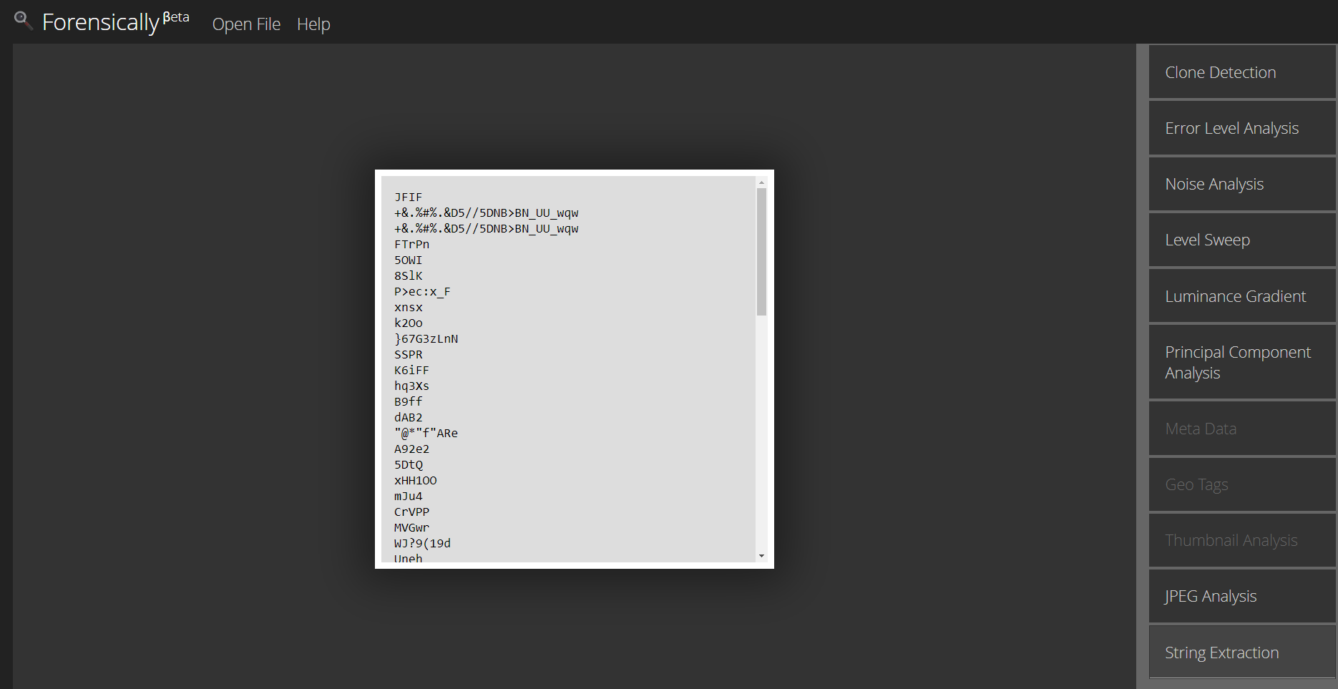

So, Forensically βeta proves that the first photo is not edited.

#### Second Photo:

##### Jeffrey's Image Metadata Viewer(<http://exif.regex.info/exif.cgi>):

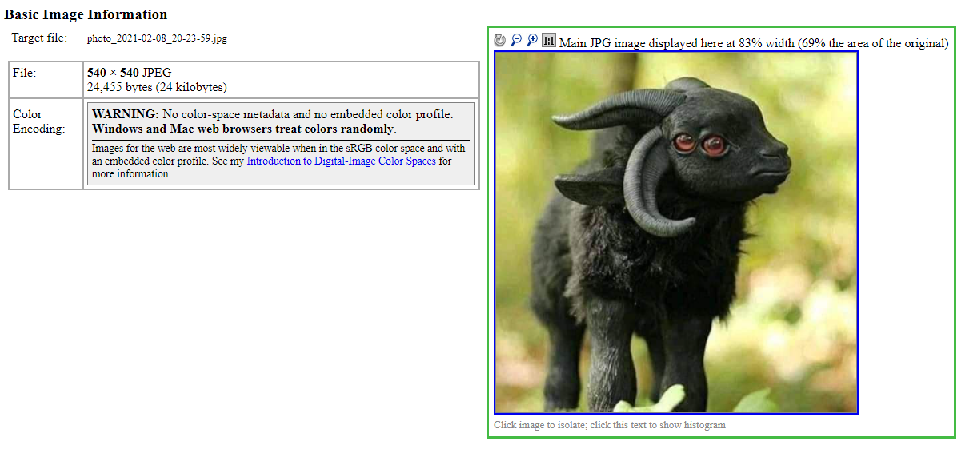

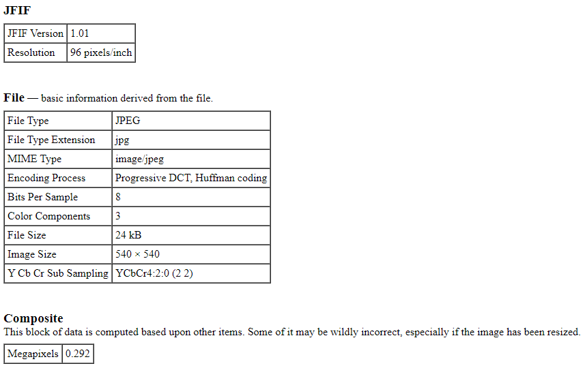

So, Jeffrey's Image Metadata Viewer proves that the second photo is not edited.

##### METADATA2GO (<https://www.metadata2go.com/>):

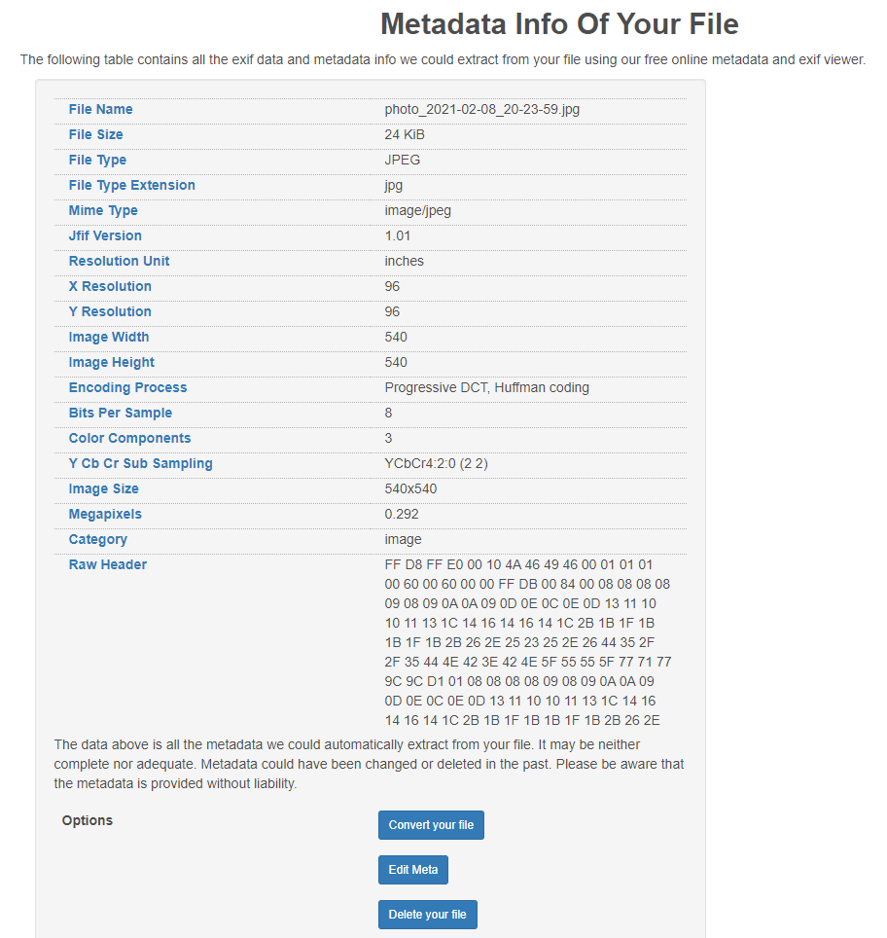So, Metadata2go proves that the second photo is not edited.

##### FotoForensics (<http://fotoforensics.com/>):

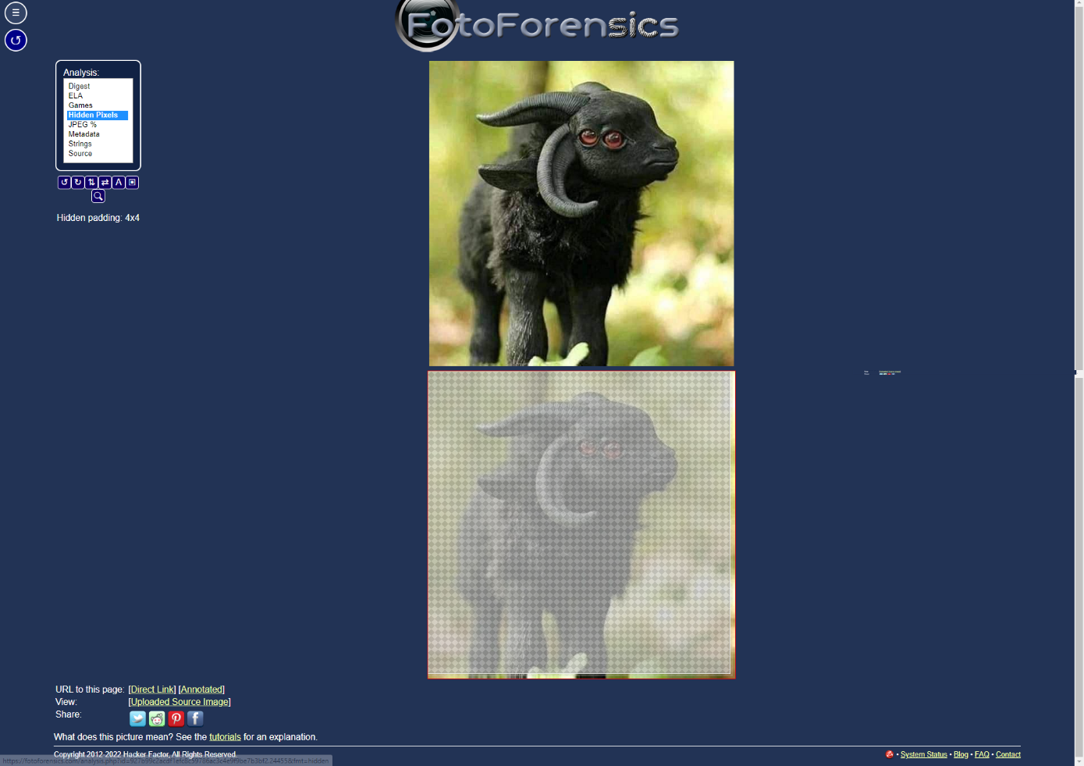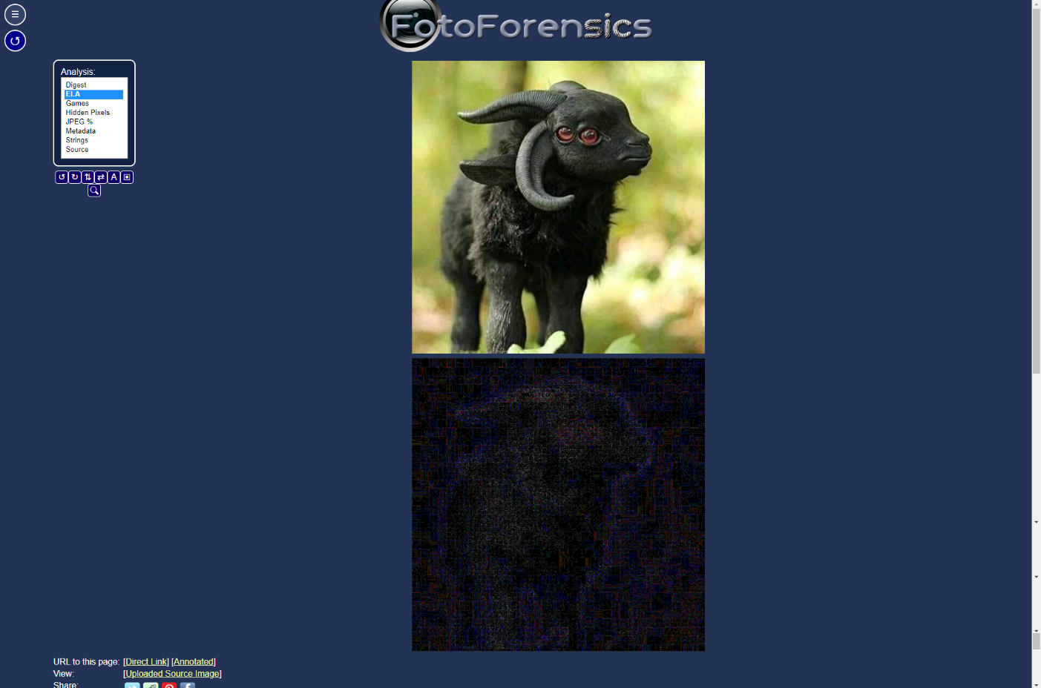

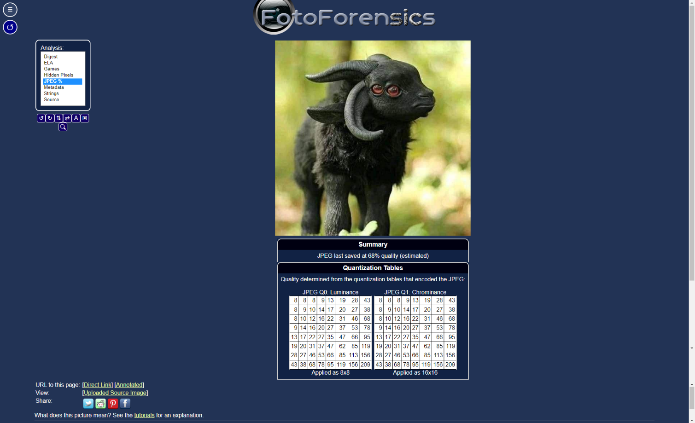

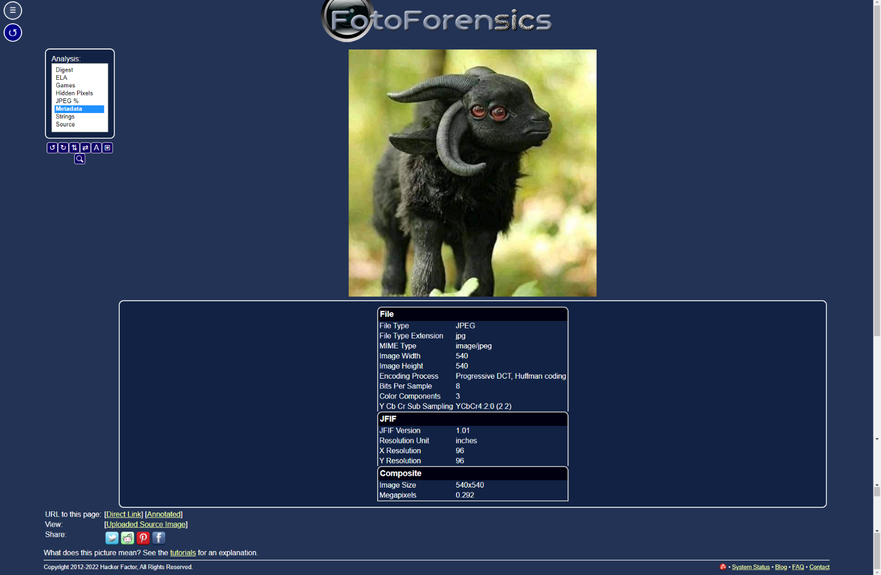

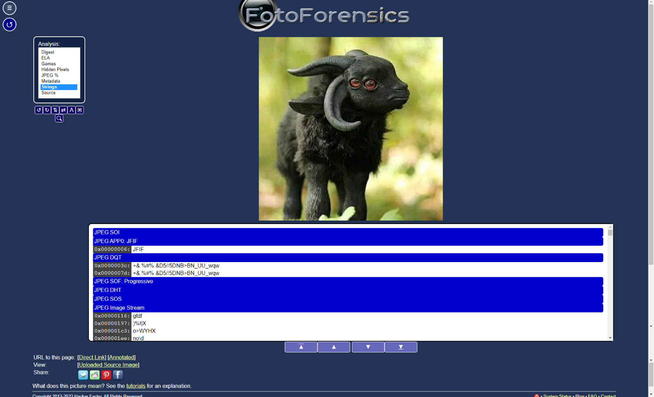

So, FotoForensics proves that the second photo is not edited.

##### Forensically βeta (<https://29a.ch/photo-forensics/#forensic-magnifier>):

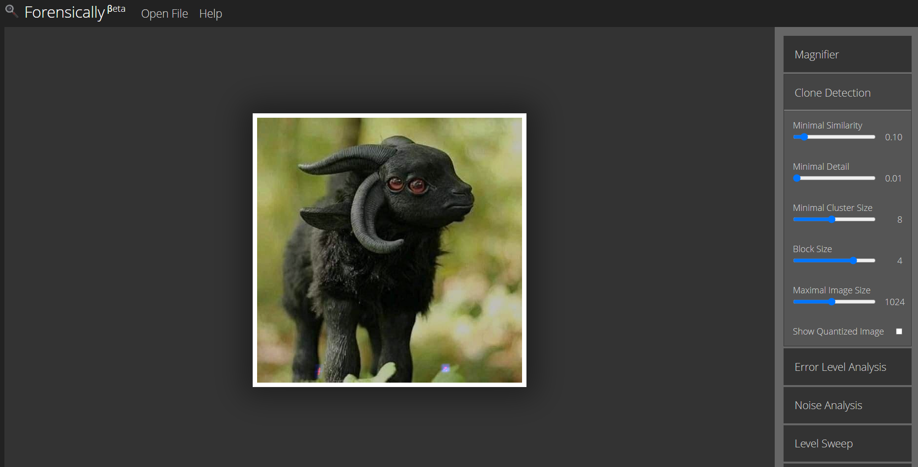

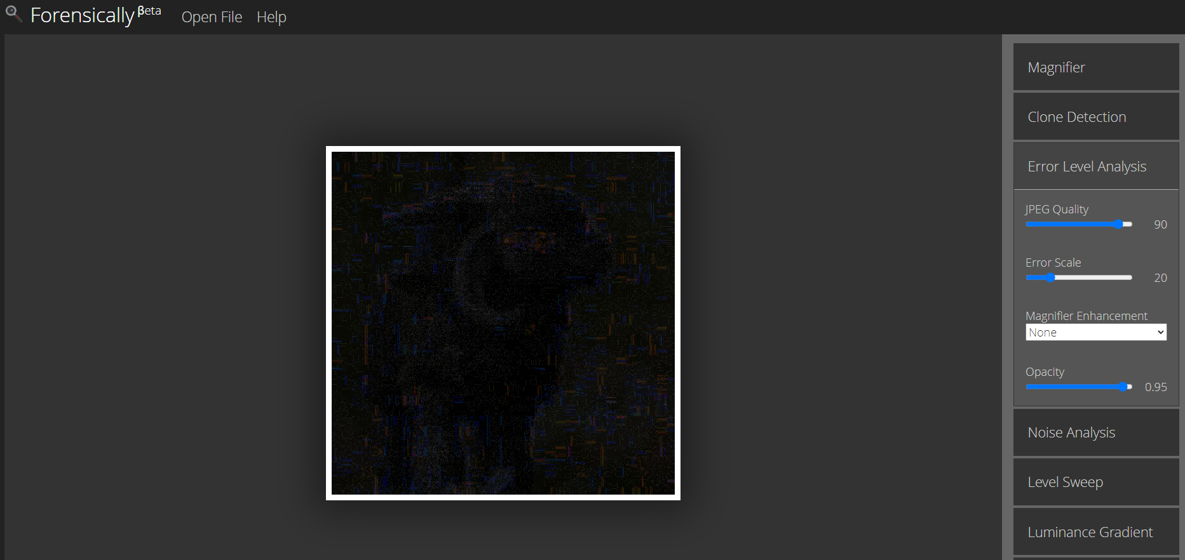

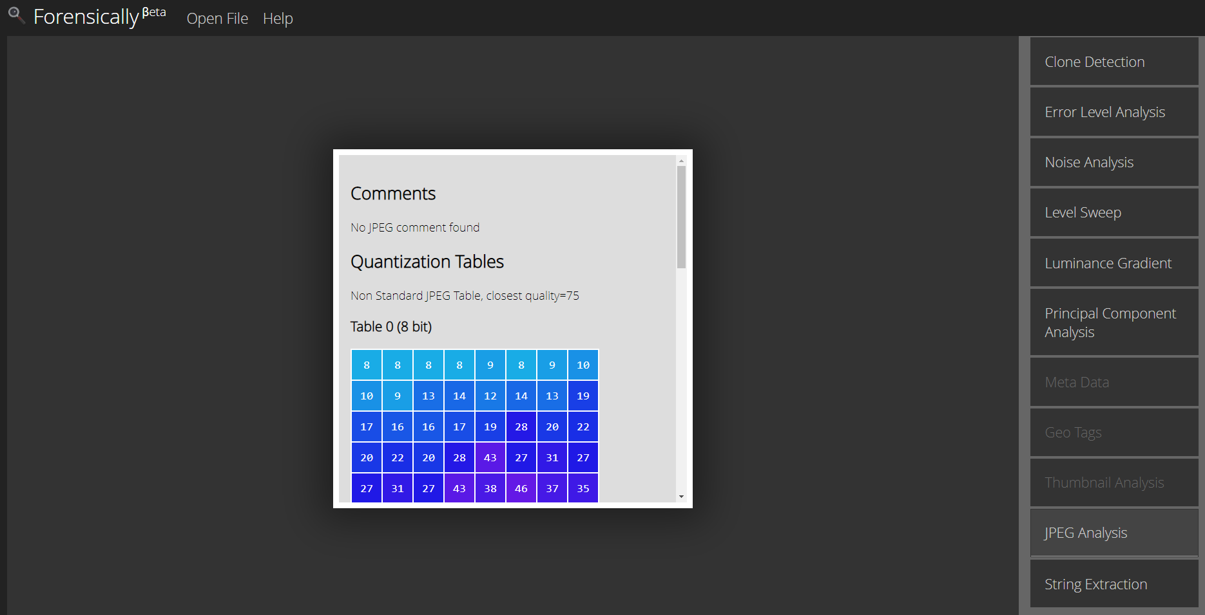

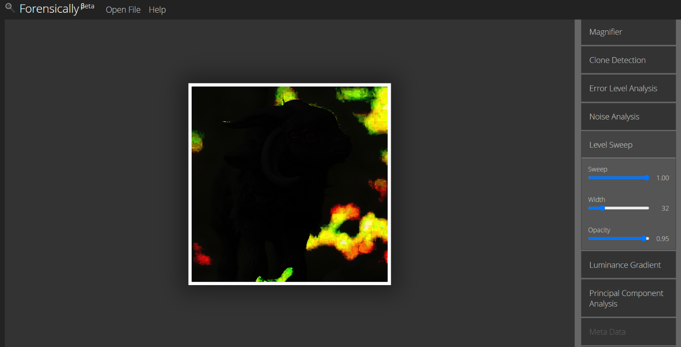

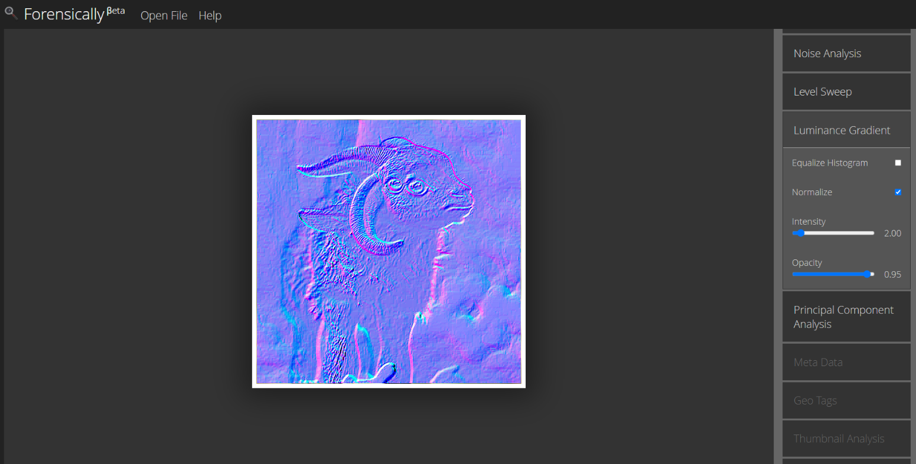

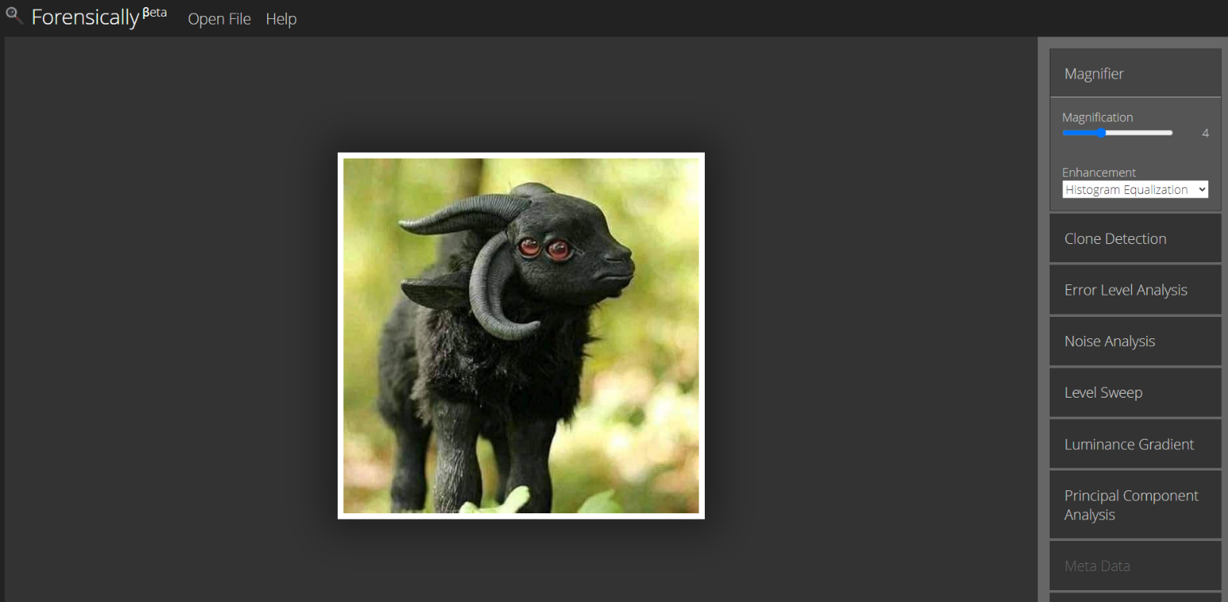

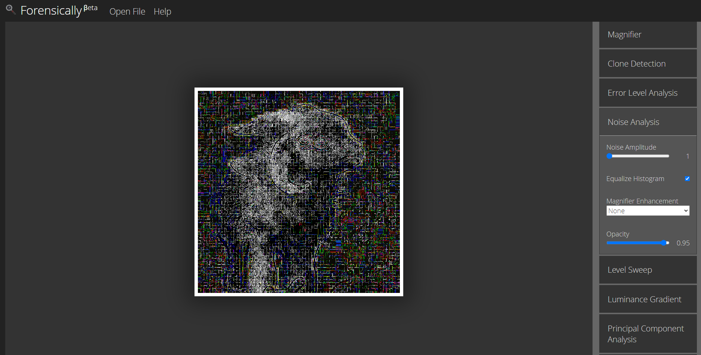

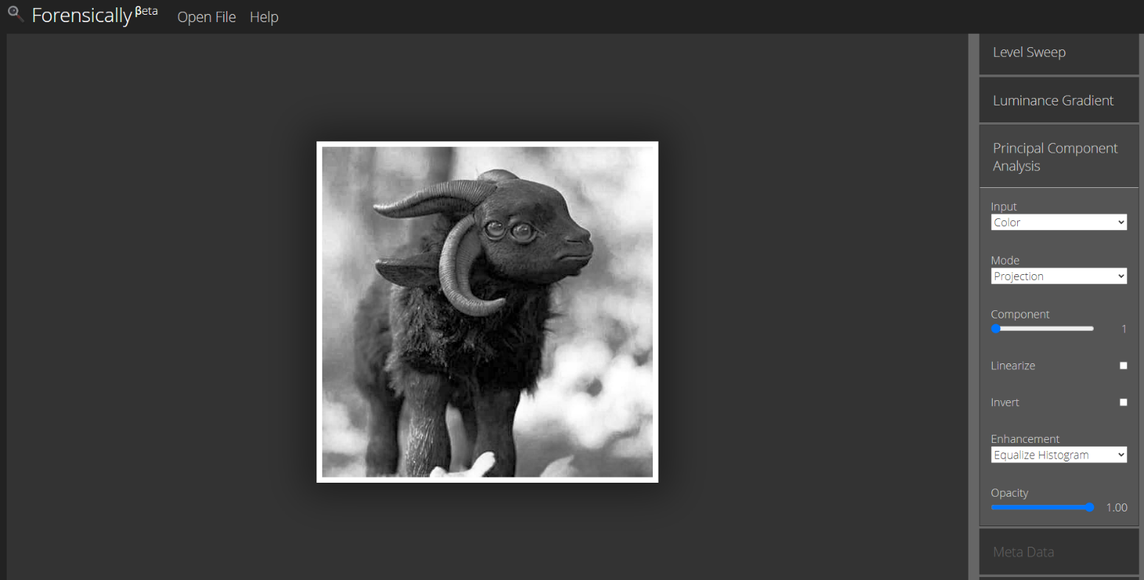

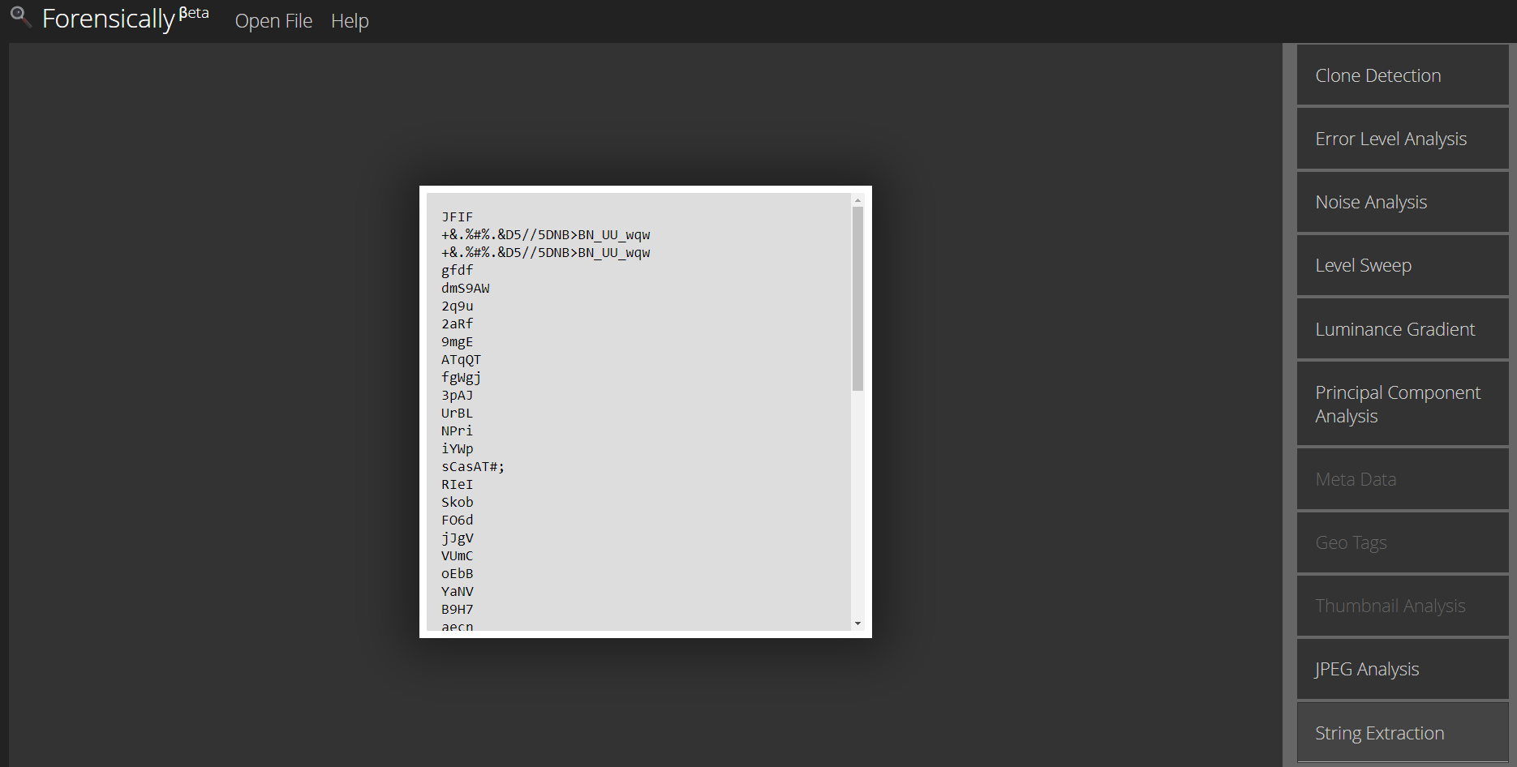

So, Forensically βeta proves that the second photo is not edited.

Thus, it proves that the photos are not edited.